**Worksheet 1 – Using the Resultant Vector of 2 Components**

1. A jet travelling at 60 m s-1 due north is hit by a side wind acting at 11.0 m s-1 west.
2. Calculate the resultant velocity of the plane if it makes no adjustments.

61 m s-1 N 10.4° W

1. Calculate the direction that the plane must steer so that the resultant velocity is due North.

N 10.6° E

1. On this new bearing, how much time is required to travel 5 km due North?

84.8 s

1. 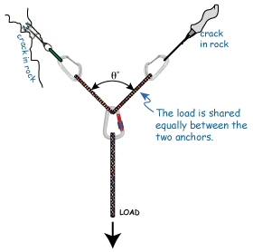The diagram shows a climbing anchor with a 1 kN load applied. The angle between the anchor ropes (θ) is 60° and the anchor ropes carry the load evenly.
2. Draw a vector diagram of the forces applied to the central carabiner.
3. Calculate the force applied to the anchor ropes.

577 N

1. If the maximum tension that an anchor rope can hold is 2.2 kN, calculate the maximum angle between the anchor ropes before they fail.

154°

1. A plane is flying due north at 65.0 m s-1 when it is hit by a wind acting due west at 16.0 m s-1.
   1. Calculate the direction that the pilot should point the aircraft to achieve a resultant velocity that is due north. You must use a vector diagram in your answer.

N 14.3° E

* 1. Calculate the magnitude of the resultant velocity north.

63.0 m s-1

1. A landing craft of mass 2000 kg is moving close to the surface of the moon, where gravitational field strength is a uniform 1.62 N kg-1. It is under the influence of gravity and can apply one 3340 N force from a thruster rocket that can point in any direction.

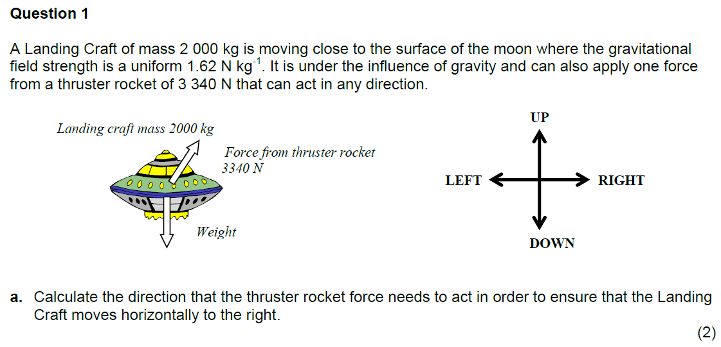

1. Calculate the direction that the thruster rocket force needs to act in order to ensure that the landing craft moves horizontally to the right.

14.1° to the right from the vertical

1. Calculate the magnitude of the resultant force acting to the right.

811 N